Network Operating Systems

Just as a computer cannot operate without a computer operating system, a network of computers cannot operate without a network operating system. Without a network operating system of some kind, individual computers cannot share resources, and other users cannot make use of those resources.

Overview
Depending on a network operating system's manufacturer, a desktop computer's networking software can be either added to the computer's own operating system like (Novell's NetWare) or integrated with it like (Windows 2000 Server/Windows 2000 Professional, Windows NT Server/Windows NT Workstation, Windows 98, Windows 95, and AppleTalk)

Coordinating Hardware and Software
A computer's operating system coordinates the interaction between the computer and the programs—or applications—it is running. It controls the allocation and use of hardware resources such as:
- Memory.
- CPU time.
- Disk space.
- Peripheral devices.
In a networking environment, servers provide resources to the network clients, and client network software makes these resources available to the client computer. The network and the client operating systems are coordinated so that all portions of the network function properly.

Software Components
For computer operating systems that do not include networking functions, network client software must be installed on top of the existing operating system. Other operating systems, such as Windows NT, integrate the network and the computer operating systems. While these integrated systems have some advantages, they do not preclude using other NOSs. When setting up multivendor network environments, it is important to consider the issue of interoperability. (Elements or components of computer operating systems are said to "interoperate" when they can function in different computer environments.) A NetWare server, for instance, can interoperate with other servers such as Windows NT, and users of Apple computers can interoperate with (that is, access resources on) both NetWare and Windows NT servers.
A network operating system such as the one shown in Figure 4.1:
- Ties together all computers and peripherals.
- Coordinates the functions of all computers and peripherals.
- Provides security by controlling access to data and peripherals.
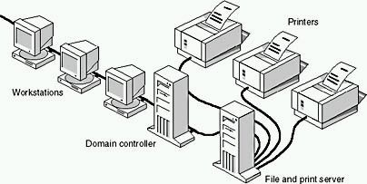
Figure 4.1 A network server ties the network together
Two major components of network software are:
- Network software that is installed on clients.
- Network software that is installed on servers.

Client Software
In a stand-alone system, when the user types a command that requests the computer to perform a task, the request goes over the computer's local bus to the computer's CPU
In a network environment, however, when a user initiates a request to use a resource that exists on a server in another part of the network, the request has to be forwarded, or redirected, away from the local bus, out onto the network, and from there to the server with the requested resource. This forwarding is performed by the redirector.
The Redirector
A redirector processes forwarding requests. Depending on the networking software, this redirector is sometimes referred to as the "shell" or the "requester." The redirector is a small section of code in the NOS that:
- Intercepts requests in the computer.
- Determines if the requests should continue in the local computer's bus or be redirected over the network to another server.
Redirector starts when the user issues a request for a network resource or service. Fig(3) shows how a redirector forwards requests to the network. The user's computer is referred to as a client because it is making a request of a server. The request is intercepted by the redirector and forwarded out onto the network.
The server processes the connection requested by client redirectors and gives them access to the resources they request. 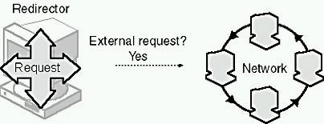
Figure 3 The redirector forwards requests for remote resources onto the network
Designators
If you need to access a shared directory, and you have permission to access it, your operating system will usually provide several choices for how to access the directory. For example, with Windows NT you could use Windows Explorer to connect to the network drive using the Network Neighborhood icon. You can also map to the drive. (Drive mapping is the assignment of a letter or name to a disk drive so that the operating system or network server can identify and locate it.) To map to the drive, right-click the directory icon from the Network Neighborhood; a dialog box will prompt you to assign an available letter of the alphabet as a drive designator, such as G:. Thereafter, you can refer to the shared directory on the remote computer as G:, and the redirector will locate it. The redirector also keeps track of which drive designators are associated with which network resources.
Peripherals
Redirectors can send requests to peripherals as well as to shared directories. Figure 4.4 depicts the redirector on a local computer sending a request to a print server. The request is redirected away from the originating computer and sent over the network to the target. In this case, the target is the print server for the requested printer.
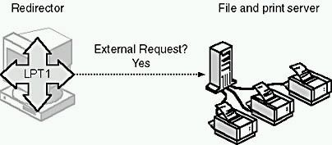
Figure 4.4 Request to print redirected out LPT1 to a printer on the network
Using the redirector, users don't need to be concerned with the actual location of data or peripherals, or with the complexities of making a connection. To access data on a network computer, for example, a user need only type the drive designator assigned to the location of the resource, and the redirector determines the actual routing.

Server Software
With server software, users at other machines, the client computers, can share the server's data and peripherals including printers, plotters, and directories.
In Figure 4.5, a user is requesting a directory listing on a shared remote hard disk. The request is forwarded by the redirector on to the network, where it is passed to the file and print server containing the shared directory. The request is granted, and the directory listing is provided.
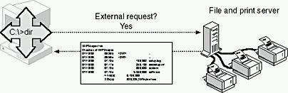
Figure 4.5 Directory-listing request on a remote hard drive
Resource Sharing
Sharing is the term used to describe resources made publicly available for access by anyone on the network. Most NOSs not only allow sharing, but also determine the degree of sharing. Options for sharing include:
- Allowing different users different levels of access to the resources.
- Coordinating access to resources to make sure that two users do not use the same resource at the same time.
Managing Users
Network operating systems also allow a network administrator to determine which people, or groups of people, will be able to access network resources. A network administrator can use the NOS to:
- Create user privileges, tracked by the network operating system, that indicate who gets to use the network.
- Grant or deny user privileges on the network.
- Remove users from the list of users that the network operating system tracks.
Managing the Network
Some advanced NOSs include management tools to help administrators keep track of network behavior. If a problem develops on the network, management tools can detect signs of trouble and present these in a chart, or other, format. With these tools, the network manager can take corrective action before the problem halts the network.

