Performance Monitoring Concepts
Regular performance monitoring ensures that you always have up-to-date information about how your computer is operating. When you have performance data for your system over a range of activities and loads, you can define a baseline#8212;a range of measurements that represent acceptable performance under typical operating conditions. This baseline provides a reference point that makes it easier to spot problems when they occur. In addition, when you are troubleshooting system problems, performance data gives you information about the behavior of system resources at the time the problem occurs, which is useful in pinpointing the cause. Finally, monitoring system performance provides you with data to project future growth and to plan for how changes in your system configurations might affect future operation. Figure 5.1 shows the sequence for monitoring different system resources.
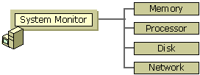

Performance console overview
The Windows Server 2003 family provides the following tools as part of the Performance console:
- System Monitor
- Performance Logs and Alerts
- Task Manager
Monitoring system performance is an important part of maintaining and administering your operating system. You use performance data to do the following:
- Understand your workload and the corresponding effect on your system's resources.
- Observe changes and trends in workloads and resource usage so you can plan for future upgrades.
- Test configuration changes or other tuning efforts.
- Diagnose problems and target components or processes for optimization.
System Monitor and Performance Logs and Alerts provide detailed data about the resources that are used by specific components of the operating system and by programs that have been designed to collect performance data. Graphs provide a display for performance-monitoring data. Logs provide recording capabilities for the data. Alerts send notification to users when a counter value reaches, rises above, or falls below a defined threshold.

Event Viewer
The Event Viewer is a tool in Windows that displays detailed information about significant events on your computer. Examples of these are programs that don't start as expected, or automatically downloaded updates. Event Viewer is especially useful for troubleshooting Windows and application errors.
Event Viewer displays these types of events:
- Error: A significant problem, such as loss of data or loss of functionality. For example, if a service fails to load during startup, an error will be logged.
- Warning: An event that is not necessarily significant, but may indicate a possible future problem. For example, when disk space is low, a warning will be logged.
- Information: An event that describes the successful operation of an application, driver, or service. For example, when a network driver loads successfully, an Information event will be logged.
- Success Audit: An audited security access attempt that succeeds. For example, a user's successful attempt to log on to the system will be logged as a Success Audit event.
- Failure Audit: An audited security access attempt that fails. For example, if a user tries to access a network drive and fails, the attempt will be logged as a Failure Audit event.
The Event Log service starts automatically when you start Windows. Application and System logs can be viewed by all users, but Security logs are accessible only to administrators.
Using the event logs in Event Viewer, you can gather information about hardware, software, and system problems and monitor Windows security events.
Task Manager

Task Manager is another tool that provides performance information about systems running the Windows Server 2003 family. Task Manager provides information about programs and processes that are running on your computer, plus a summary of its processor and memory usage. For information about Task Manager
. Task Manager, previously known as Windows Task Manager is a task manager, system monitor and startup managerincluded with Microsoft Windows systems. It provides limited information about computer performance and running applications, processes and CPU usage, commit charge and memory information, network activity and statistics, logged-in users, and system services. The Task Manager can also be used to set process priorities, processor affinity, forcibly terminate processes, and shut down, restart, hibernate or log off from Windows. Windows Task Manager was introduced with Windows NT 4.0. Previous versions of Windows NT included the Task List application, which had far fewer features. The task list was capable of listing currently running processes and killing them, or creating a new process. In Windows XP only, a Shutdown menu is also present that allows access to Standby, Hibernate, Turn off, Restart, Log Off and Switch User.
Windows 3.x and Windows 9x had a program known as tasks to display the programs currently running. This file was executed by running the taskman.exe file from the C:\Windows directory.^{[1]}
The program can be started in recent versions of Windows by pressing WIN+R and then typing in taskmgr.exe, by pressingCTRL+ALT+DEL and clicking Start Task Manager, or by pressing CTRL+SHIFT+ESC.
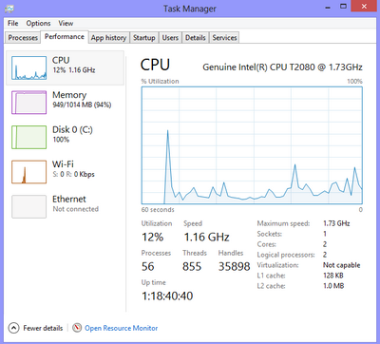
Microsoft technical support often uses the results of performance monitoring in problem diagnosis. Therefore, Microsoft recommends that you monitor system performance as part of your administrative routine.

