**IP Addressing**

**Internet Protocol:**

* Protocol: The rules that govern computer communications. It defines how to identify individual computers, initiate and end networked communication, and manage information exchange across network medium.
* Internet Protocol (IP) is a protocol that provides source and destination addressing and routing for the TCP/IP protocol suite. It defines logical addresses called IP addresses.
* **IP version 4**:

An IP address is an identifier that is assigned at the Internet layer to an interface or a set of interfaces. Each IP address can identify the source or destination of IP packets. For IPv4, every node on a network has one or more interfaces, and you can enable TCP/IP on each of those interfaces. When you enable TCP/IP on an interface, you assign it one or more logical IPv4 addresses, either automatically or manually. The IPv4 address is a logical address because it is assigned at the Internet layer and has no relation to the addresses that are used at the Network Interface layer. IPv4 addresses are 32 bits long.

**IPv4 Address Syntax**

If network administrators expressed IPv4 addresses using binary notation, each address would appear as a 32-digit string of 1s and 0s. Because such strings are cumbersome to express and remember, administrators use dotted decimal notation, in which periods (or dots) separate four decimal numbers (from 0 to 255). Each decimal number, known as an octet, represents 8 bits (1 byte) of the 32-bit address. For example, the IPv4 address 11000000101010000000001100011000 is expressed as 192.168.3.24 in dotted decimal notation. To convert an IPv4 address from binary notation to dotted decimal notation, you:

* Segment it into 8-bit blocks:

11000000 10101000 00000011 00011000

* Convert each block to decimal: 192 168 3 24
* Separate the blocks with periods: 192.168.3.24

When referring to an IPv4 address, use the notation w.x.y.z.

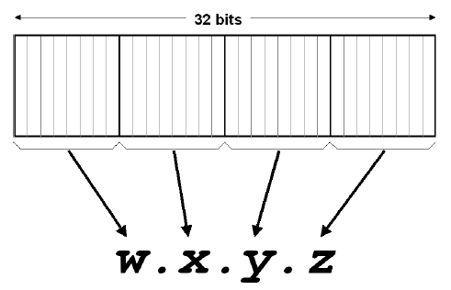

**Special IPv4 Addresses**

The following are special IPv4 addresses:

* **0.0.0.0**

Known as the unspecified IPv4 address, it indicates the absence of an address. The unspecified address is used only as a source address when the IPv4 node is not configured with an IPv4 address configuration and is attempting to obtain an address through a configuration protocol such as DHCP.

* **127.0.0.1**

Known as the IPv4 loopback address, it is assigned to an internal loopback interface. This interface enables a node to send packets to itself.

* Find the error, if any, in the following IPv4 addresses.

**Solution:**

a. There must be no leading zero (045).

b. There can be no more than four numbers.

c. Each number needs to be less than or equal to 255.

d. A mixture of binary notation and dotted-decimal  
 notation is not allowed.



* Change the following IPv4 addresses from binary notation to dotted-decimal notation.



Solution:



* Change the following IPv4 addresses from dotted-decimal notation to binary notation.



Solution: We replace each decimal number with its binary equivalent



**IP Address Classes:**

* IP addresses are categorized in ranges referred to as Classes A, B, C, D, or E.
* The class system is a basis for determining which part of an IP address is the network ID and which part is the host ID.

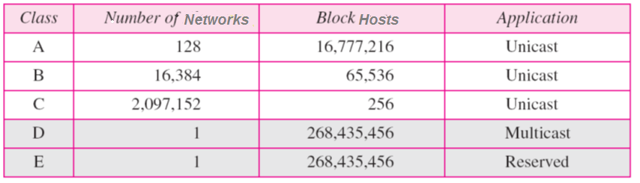

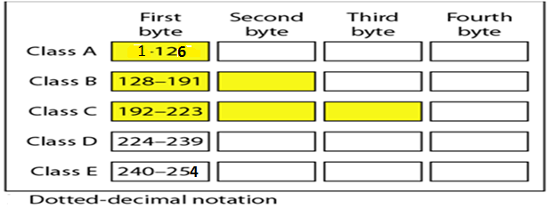



* Find the class of each address.

**Solution:**

a. The first bit is 0. This is a class A address.

b. The first 2 bits are 1; the third bit is 0. This is a class C address.

c. The first byte is 14; the class is A.

d. The first byte is 252; the class is E.

a. 00000001 00001011 00001011 11101111

b. 11000001 10000011 00011011 11111111

c. 14.23.120.8

d. 252.5.15.111

**Special/reserved addresses:**

Are addresses that can’t be assigned to a computer:

**1)** **Network number address**: the address in which all host ID bits are binary 0s

e.g:198.44.19.0

**2)** **Directed broadcast address**: the address in which all host ID bits are binary 1s.

e.g:198.44.19.255

**3)** **Limited broadcast address**: the address in which all network ID & host ID bits are binary 1s. e.g:255. 255. 255.255

**4) This computer address:** the address in which all network ID & host ID bits are binary 0s. Used when the computer need to know its address.

**5) Loopback address** any address in the 127.0.0.0 network (except 127.0.0.0 and 127.255.255.255 in most OSs) references the local machine. e.g.:- 127.0.0.1

**Subnet Masks:**

• IP uses an address’s **subnet mask to determine** which part of the address identifies the network portion and which part identifies the host portion.

• Subnet masks are 32-bit numbers in dotted decimal format

– Default subnet mask for Class A is 255.0.0.0

– Default subnet mask for Class B is 255.255.0.0

– Default subnet mask for Class C is 255.255.255.0

* By altering the subnet mask, the network ID has been altered.
* Example: If a computer has the IP address 153.92.100.10 and the subnet mask is 255.255.0.0 then the network portion is 153.92 and the host portion is 100.10

• Example (continued): Using the same address of 153.91.100.10 but with a subnet mask of 255.255.255.0, the network portion is now 153.92.100 and the host portion is 10.

* **Octet Format**

IP address is divided into Network and Host Portion.

* CLASS A is written as N.H.H.H.
* CLASS B is written as N.N.H.H.
* CLASS C is written as N.N.N.H.

Default masks for classful addressing:



**Types of Broadcasting**

1- UniCast 1---1

2- MultiCast 1--- Group

3- anycast One of the Group

4- BroadCast 1--- All

**Internet Protocol Version 6:**

* IPv6 solves some problems in IPv4:

– Limits of the 32-bit address space

– Lack of built-in security

– Complicated setup

• An IPv6 address is 128 bits instead of 32 bits in IPv4

– 2^128 = 3.4 * 10^38

– 2^32 = 4.2 * 10^9

* Pv6 is 128 bits long specified in hexadecimal format in 16-bit sections separated by a colon Example: 2001:1b20:302:442a:110:2fea:ac4:2b
* IPv6 is auto configuring (no IP address to assign and no subnet mask to determine)
* An addressing hierarchy of three parts is used: a public topology, a site topology, and an interface identifier.
* The first three 16-bit sections (totaling 48 bits) represent the public topology, which could be an Internet backbone service provider.
* The next 16 bits represent the site topology, such as a business or a local ISP.
* The last 64 bits (four 16-bit sections) represent the interface identifier, it’s a unique host address.

